**SENTIMENTAL ANALYSIS ON AMAZON REVIEWS**

* Sentiment Analysis is a type of classification where the data is classified into different classes.
* The process of classifying whether a block of text is positive, negative, or, neutral.
* Sentiment Analysis is required as it stores data in an efficient, cost-friendly.
* Sentiment analysis solves real-time issues and can help you solve all the real-time scenarios.

**Types of Sentimental Analysis?**

* **Fine-grained sentiment analysis :** This category can be designed as very positive, positive, neutral, negative, very negative.
* **Emotion detection :** The sentiment happy, sad, anger, upset, jolly, pleasant, and so on come under emotion detection.
* **Aspect based sentiment analysis** : It focuses on a particular aspect like for instance.
* **Multilingual sentiment analysis :** Multilingual consists of different languages where the classification needs to be done as positive, negative, and neutral.

**Importance of Sentimental Analysis**

* Sentiment analysis tools are essential to detect and understand customer feelings.
* Upselling opportunities:Happy customers are more likely to be receptive to upselling.
* Sentiment analysis scoring puts a quantifiable number on customer satisfaction.
* This sentiment type finds the customers’ feelings within the text or responses provided.

**Sentimental Analysis Code**

#Used Amazon reviews Exporter in google chrome to extract reviews

**#Importing file into R**

**#load packages into R**

#install.packages("tm")

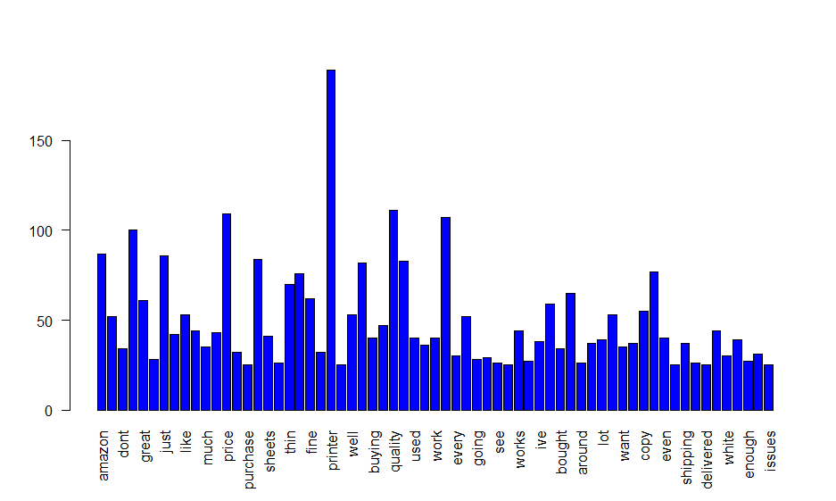#install.packages("wordcloud")

#install.packages("syuzhet")

library(tm) # text analytics- text mining.

library(wordcloud) # create wordcloud

library(syuzhet)

**#import data in R**

reviews<-read.csv(file.choose(), header = T )

#check the structure of file

str(reviews)

**#Creating Corpus**

#This function uses the base package function iconv to translate value labels into a specified value

corpus <- iconv(reviews$review.text)

corpus<-Corpus(VectorSource(corpus))

#To see the corpus

inspect(corpus[1:5])

**#Cleaning Corpus**

corpus <- tm_map(corpus, tolower)

#inspect(corpus[1:5])

corpus <- tm_map(corpus, removePunctuation)

#inspect(corpus[1:5])

corpus <- tm_map(corpus, removeNumbers)

#inspect(corpus[1:5])

corpus <- tm_map(corpus, removeWords, stopwords("english"))

#inspect(corpus[1:5])

#Remove some common words not to used in text analysis - replace word 1, word 2 by actual words

corpus <- tm_map(corpus, removeWords, c("pages","paper"))

#inspect(corpus[1:5])

corpus <- tm_map(corpus, stripWhitespace)

inspect(corpus[1:5])

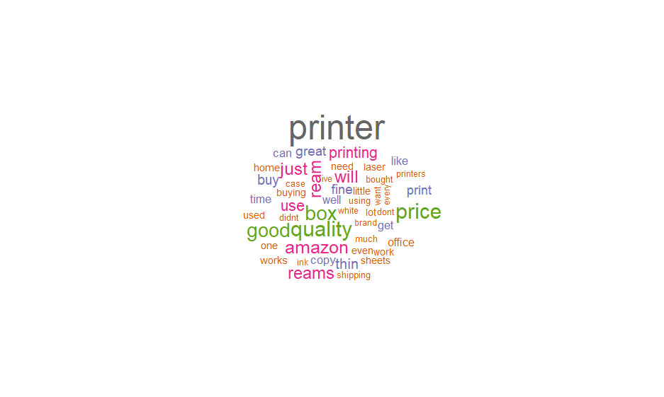reviews_final <- corpus

**#Create a term document**

tdm <- TermDocumentMatrix(reviews_final)

tdm<-as.matrix(tdm)

tdm[1:10, 1:5]

**#Bar PLots**

w <- rowSums(tdm)

w<-subset(w, w>=25)

barplot(w, las = 2, col = "blue")

**#create word cloud**

w<- sort(rowSums(tdm), decreasing = T)

set.seed(2000)

wordcloud(words = names(w), freq = w,

max.words = 50, random.order = T,

min.freq = 5, colors = brewer.pal(25,"Dark2"),

scale = c(3,0.3))

**#obtain sentiment scores**

sentiment_data <- iconv(reviews$review.text)

s<-get_nrc_sentiment(sentiment_data)

s[1:10,]

#calculate review wise score

s$score <- s$positive - s$negative

s[1:10,]

**#write scores into a csv file**

write.csv(x = s, file = "Downloads/reviews (1).csv")

**#check product sentiment**

#check overall sentiment of the product

review_score <- colSums(s[,])

print(review_score)

#Plot product sentiment

**#Bar plot**

barplot(colSums(s),

las = 2,

col= rainbow(10),

ylab = 'Count',

main = 'Sentiment')

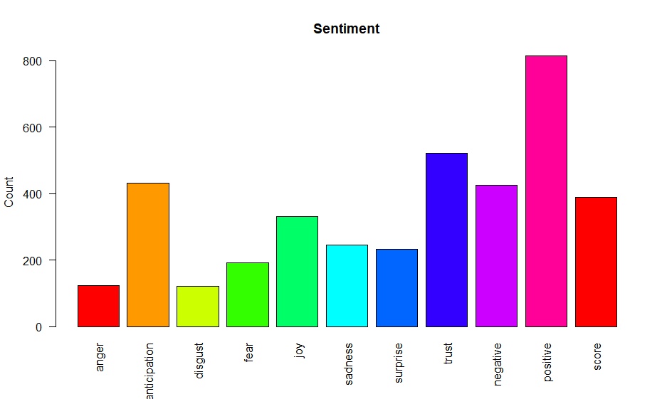

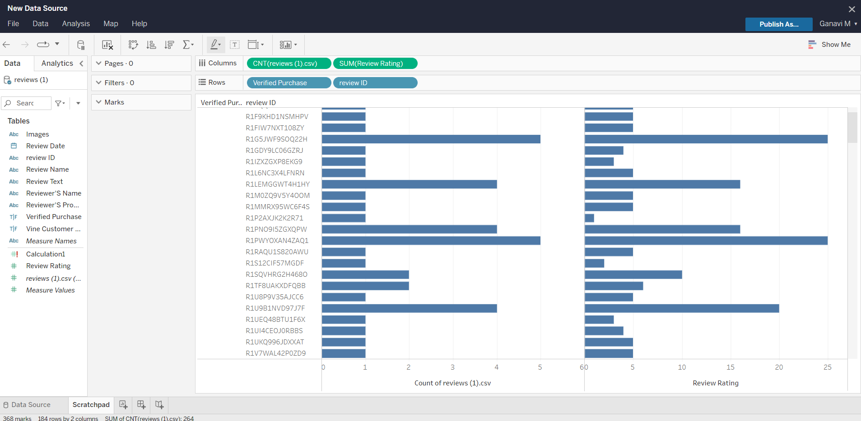**TABLEAU ANALYSIS**

